1.5 I can follow instructions and act accordingly to requests in work situation has your line manager given you instruction to carry out

Planning a Gantt Chart

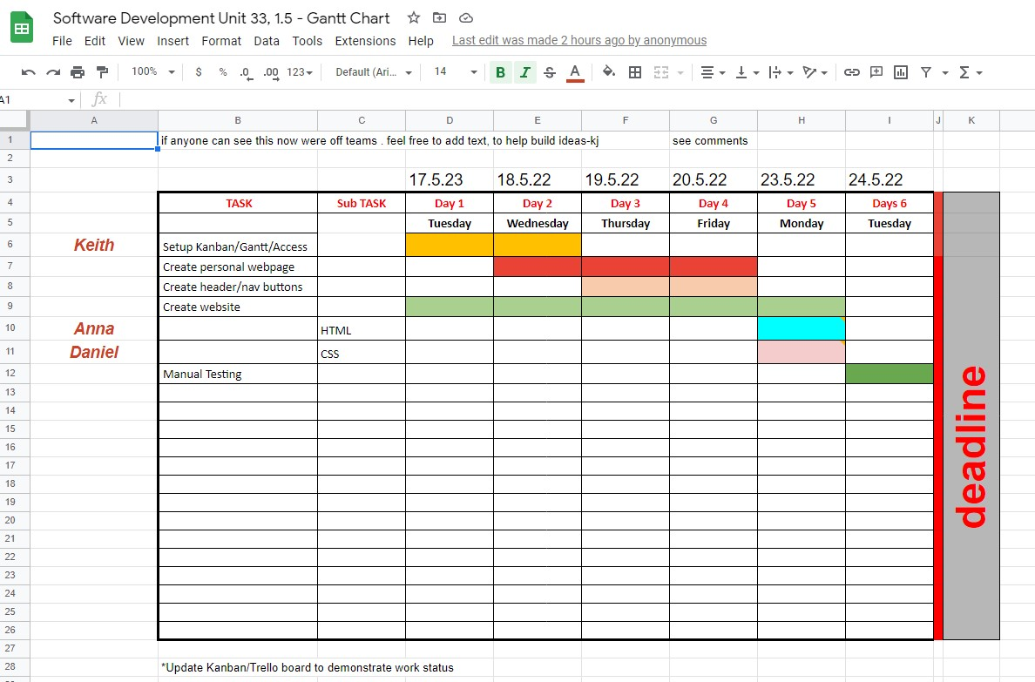

A Gantt chart example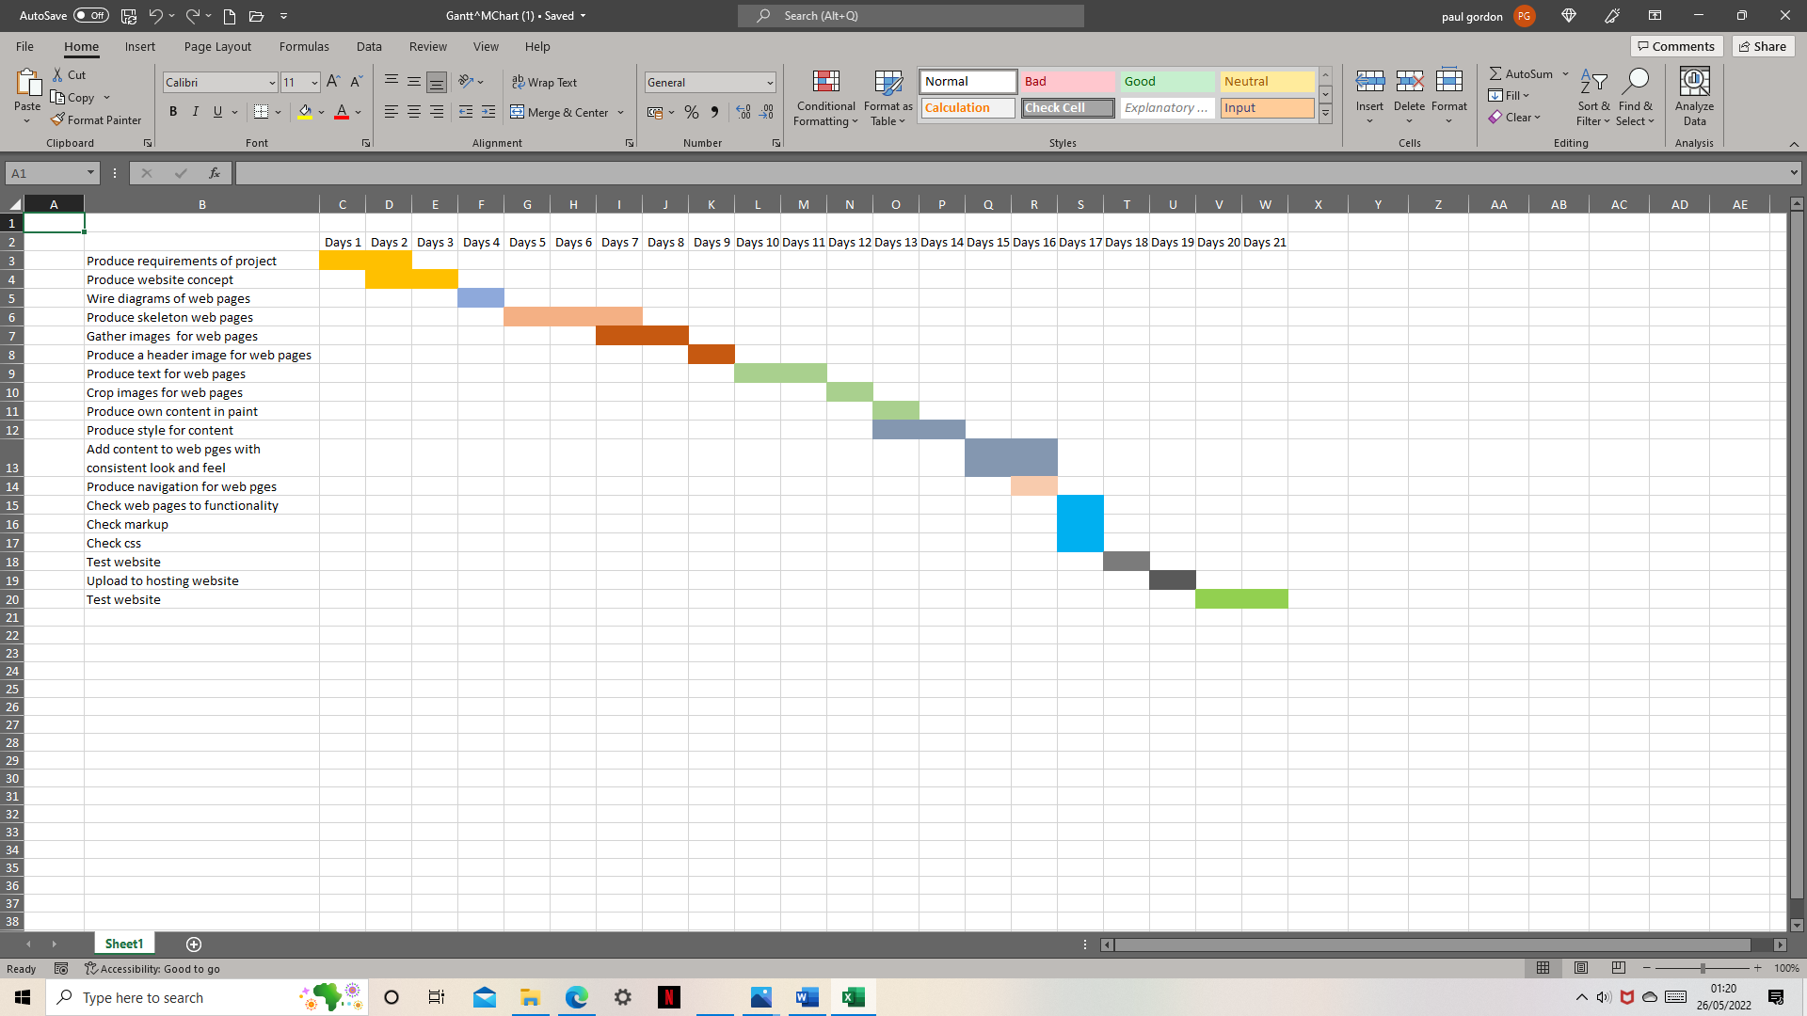

We started off with a breakout room which wasn’t good for group collaboration, we had to produce our where own webpage for the website collaboration using html and CSS

which Anna and Daniel took in charge of

17/5/22 Anna invited us to join Trello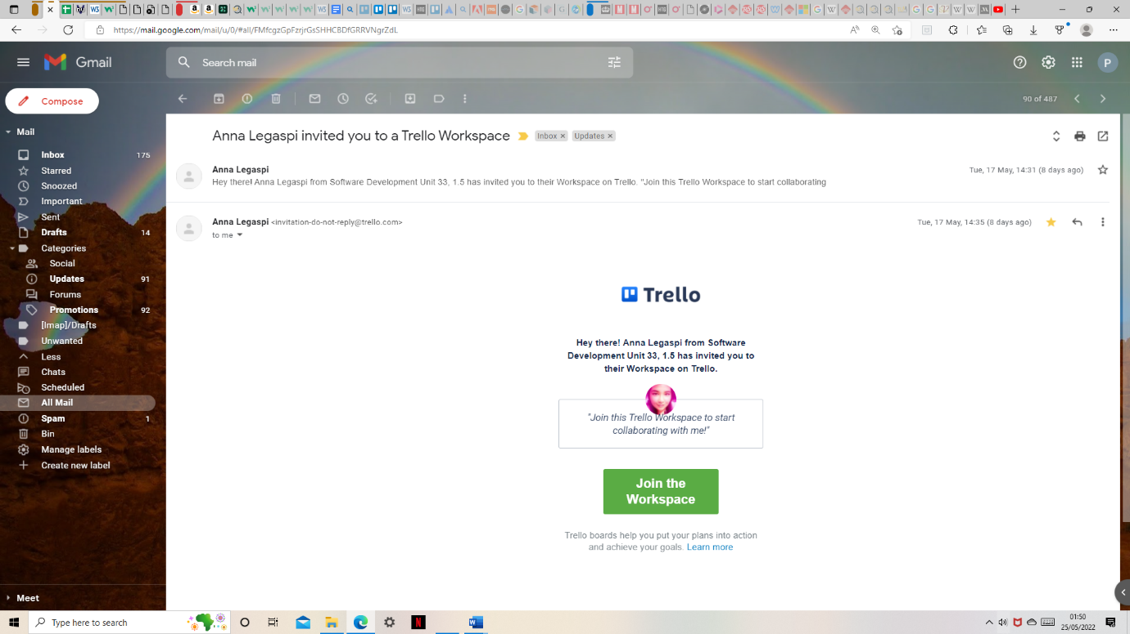

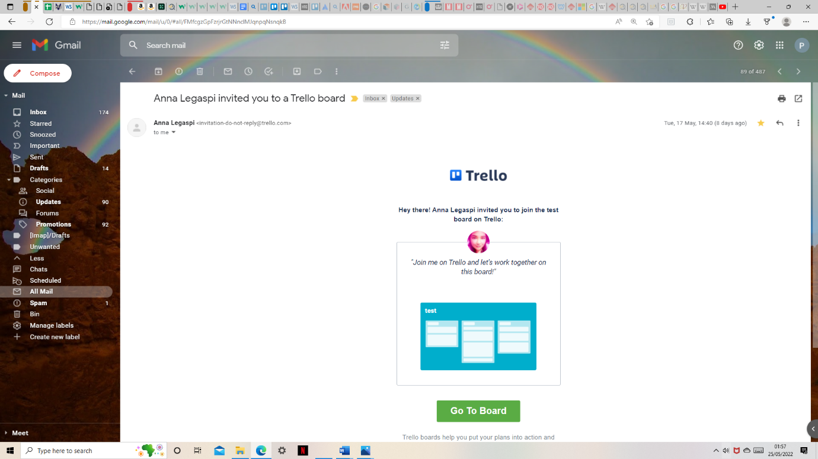

18/05/22 Daniel Powis added to the card accessibility on all pages 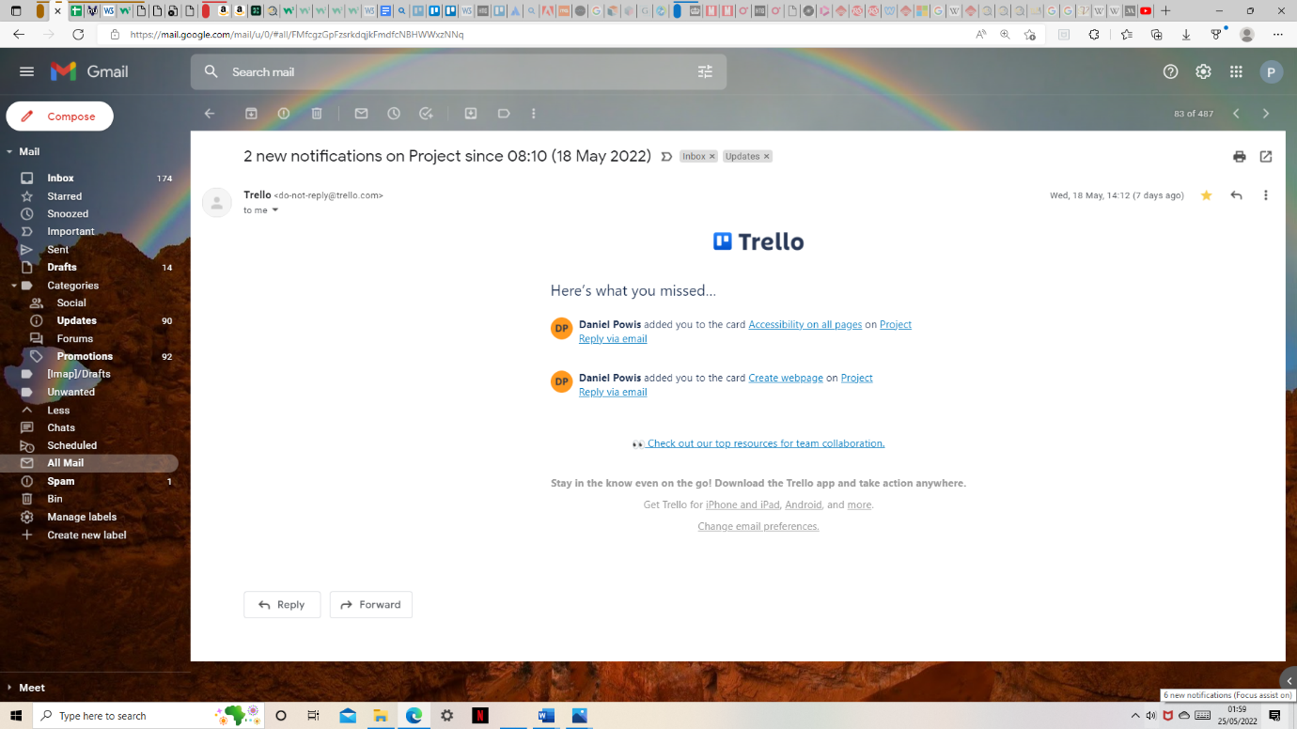

Daniel Powis added me to the card create webpages 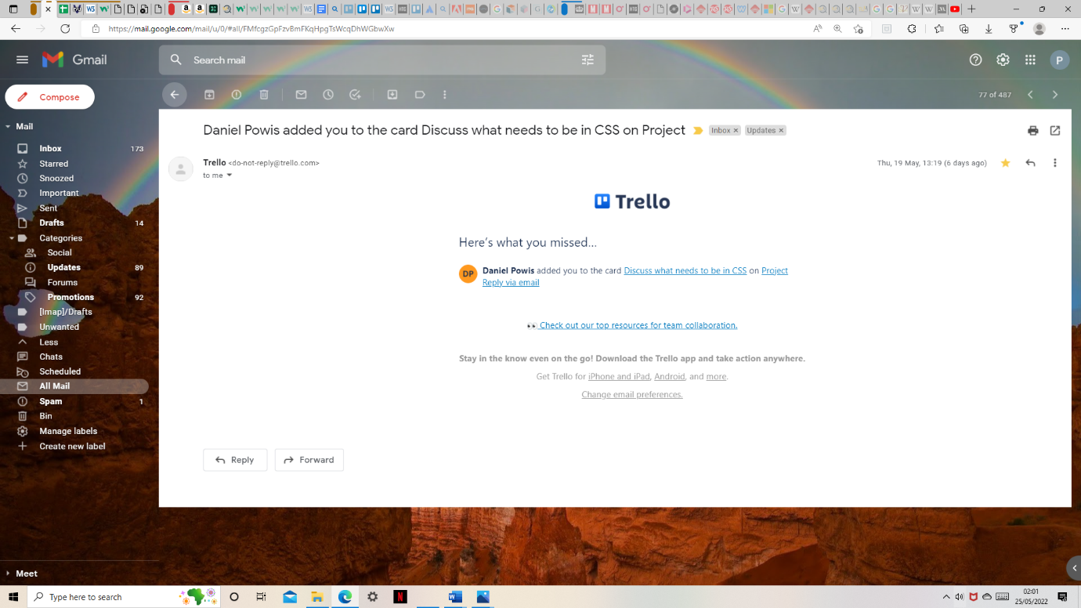

19/05/22 Anna returned her email reply back to my email address

19/05/22 Trello update from Dan added me to the card discuss what needs to be in CSS

Team meeting 19/05/22 arrange by Shafiq 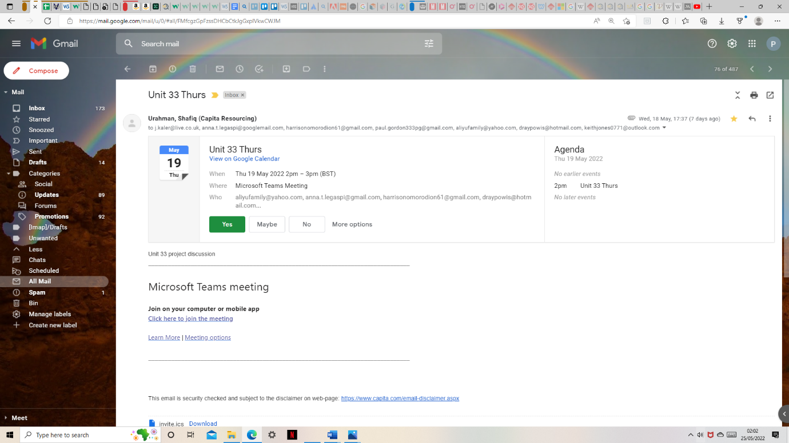

19/05/22 Update on Trello from Jay accessibility page Anna moved the card create webpage to doing on project Anna moved the card accessibility on all pages to doing on project 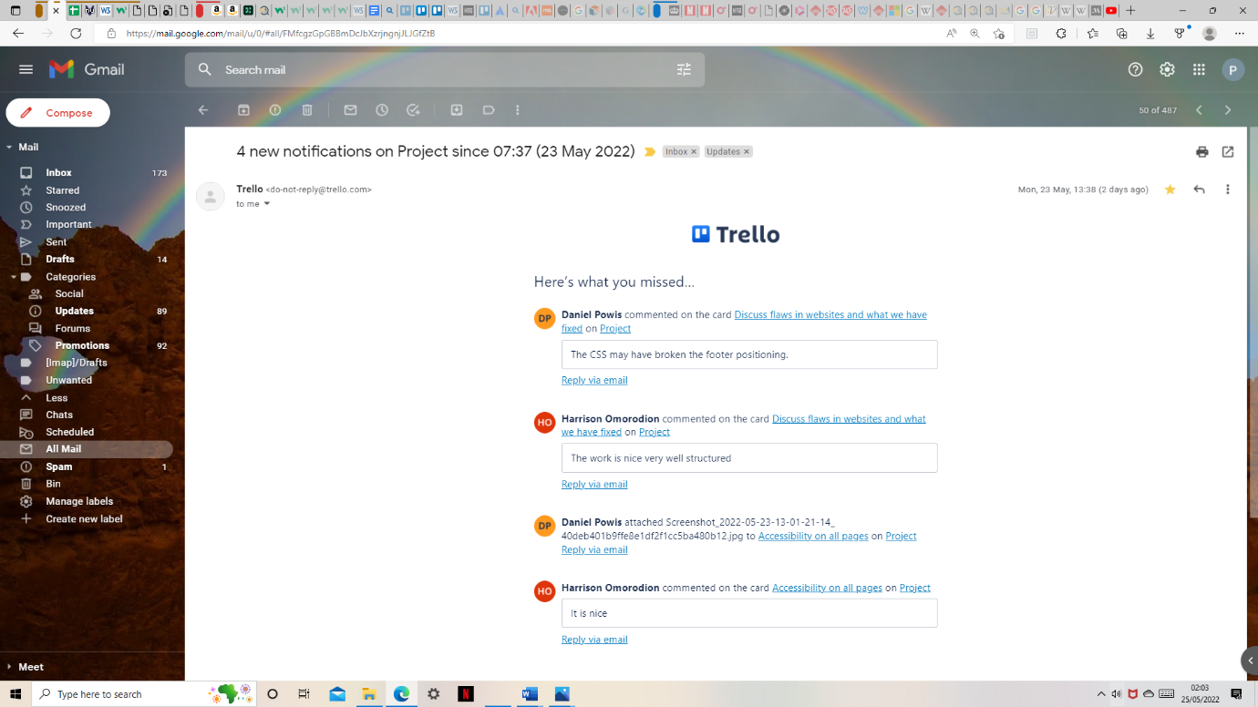

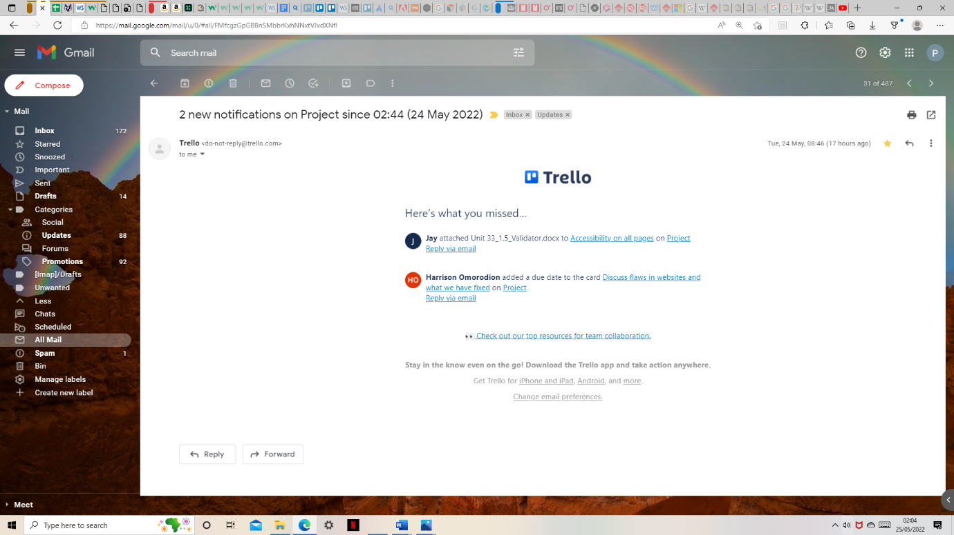

19/05/22 teams meeting by Shafiq

20/05/22 Trello by Daniel update discuss what needs to be in CSS vs HTML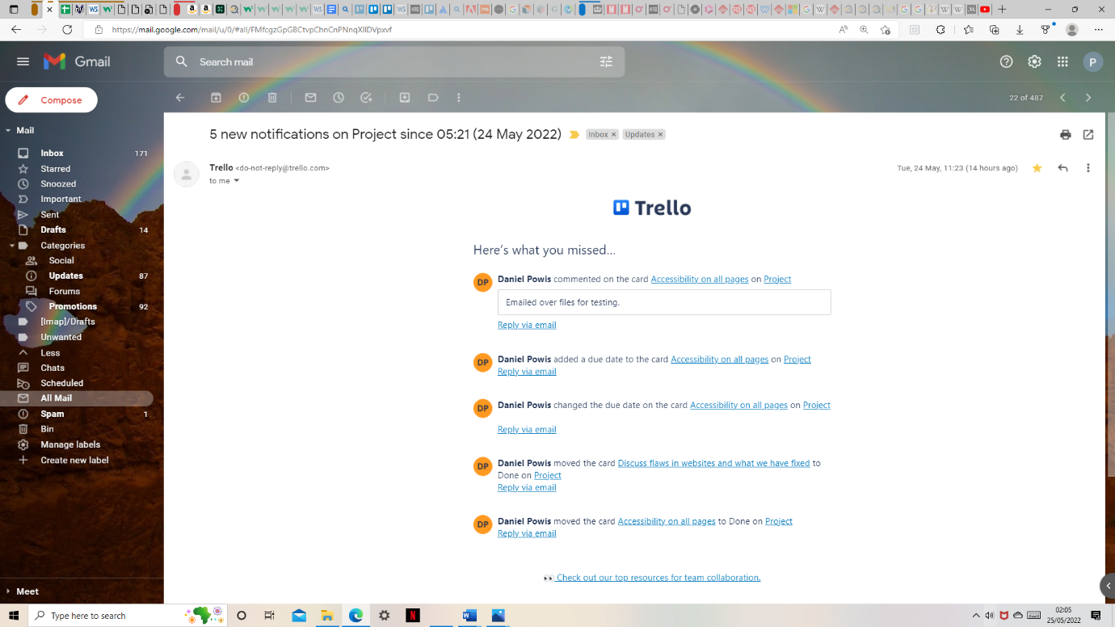



20/05/22 Harrison Trello discuss what needs to be in CSS vs HTML 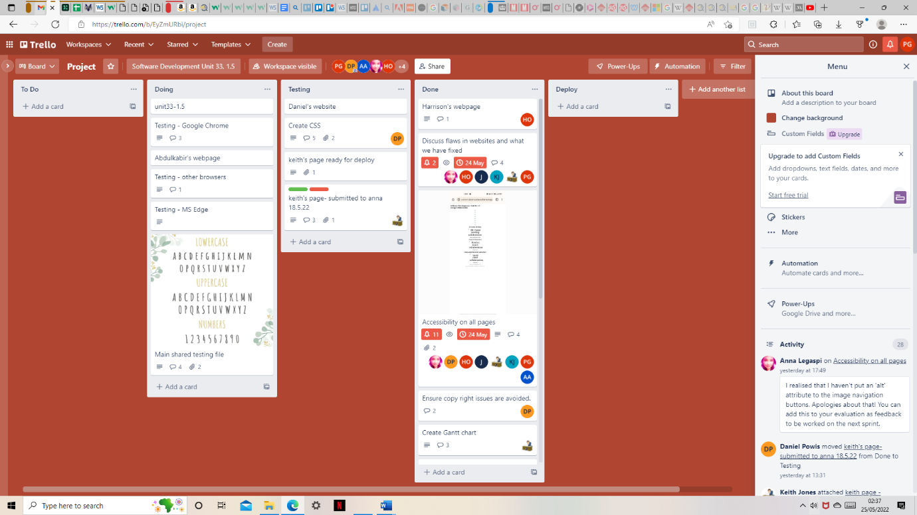

20/05/22 Invite by Anna on Trello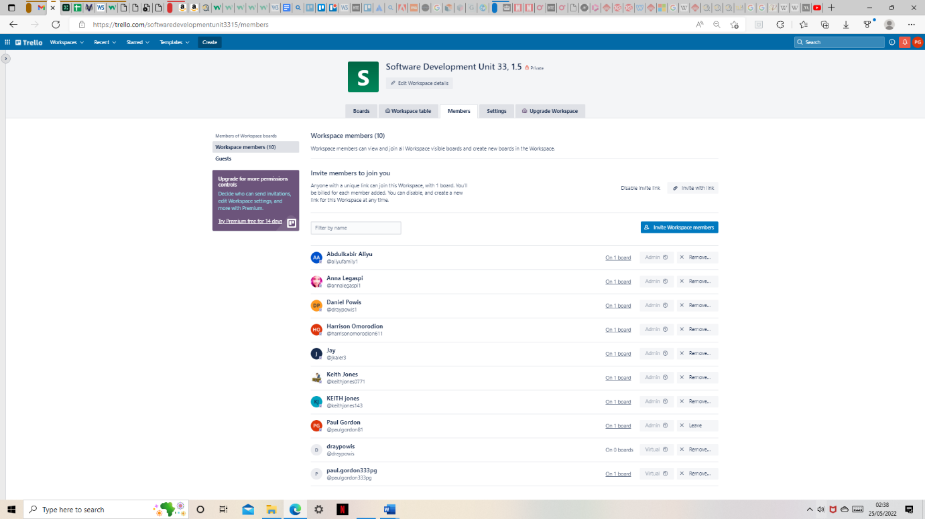

20/05/22 Trello invite Daniel discuss what needs to be in CSS vs HTML

21/05/22 Trello Daniel Powis invited you to a Trello board meeting

21/05/22 Trello Daniel discuss flaws in website and what we have to fix